A Maths-No Problem! Help Guide
This is a guide to help with daily maths lessons using the Maths-No Problem Textbooks and Workbooks. You should have already received an email from Maths-No Problem asking you to sign up and create a password; if you have not, then please inform School via email.

When you sign in you will be greeted with this screen. It should have the initials of your children after the welcome.

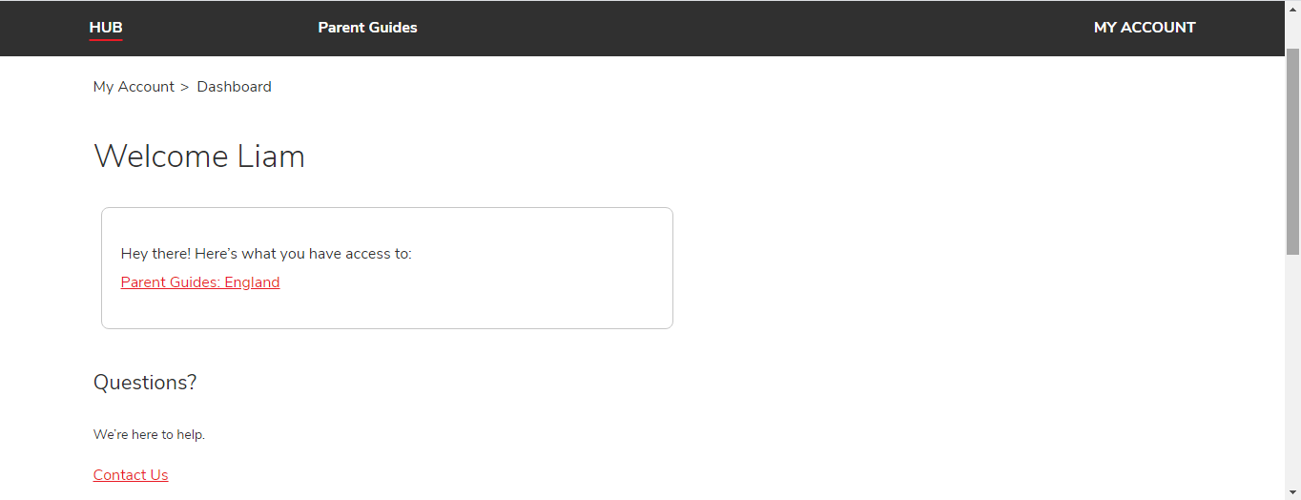

So if you have John and Wendy in the school, it should say Welcome J+W. You should now click on Parent Guides: England.

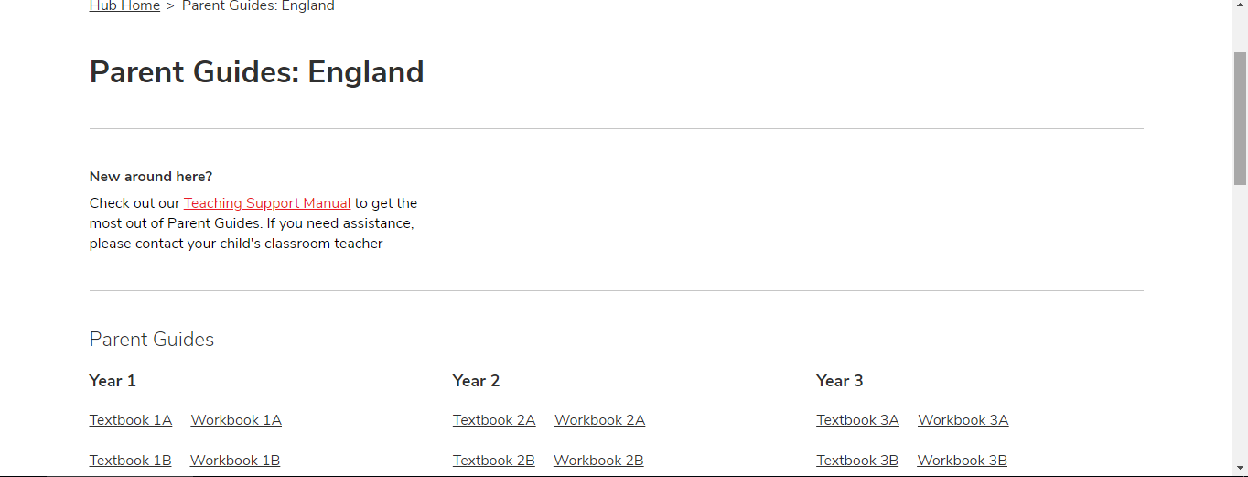

This will take you to where you can access your child’s Year Group Textbooks and Workbooks. You should only have access to the Year groups in which you have children in. It will be put on the weekly unit on the school website which lessons should be covered on which days by the Year Group teams. You should start off by clicking on the Textbook options. For example, the Year 3 Team may ask you to look at Textbook 3A, which you can click on and taken to this textbook’s contents page.
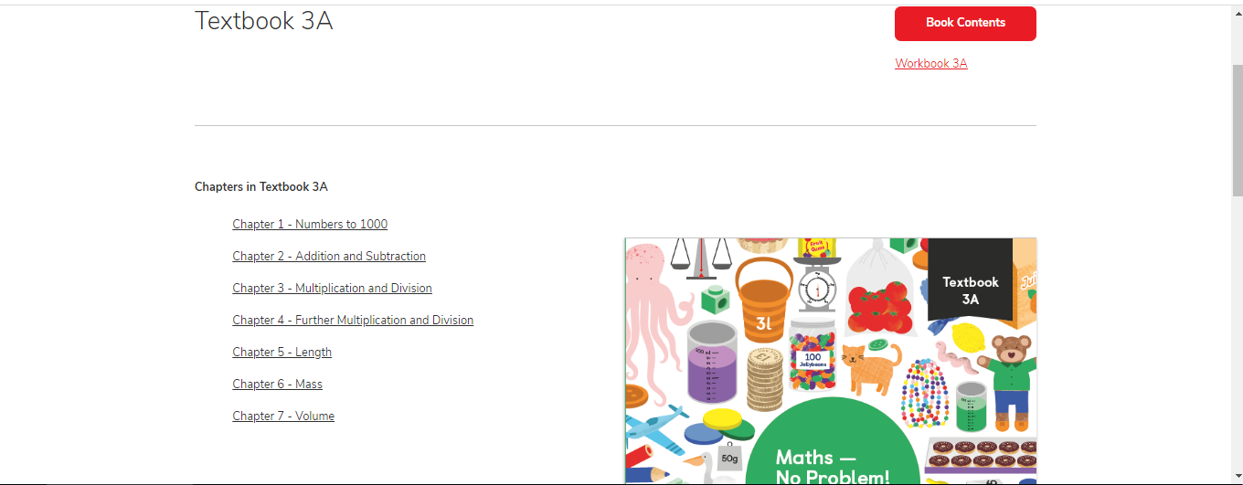
You will also be given a chapter to look at. You can select this chapter next.

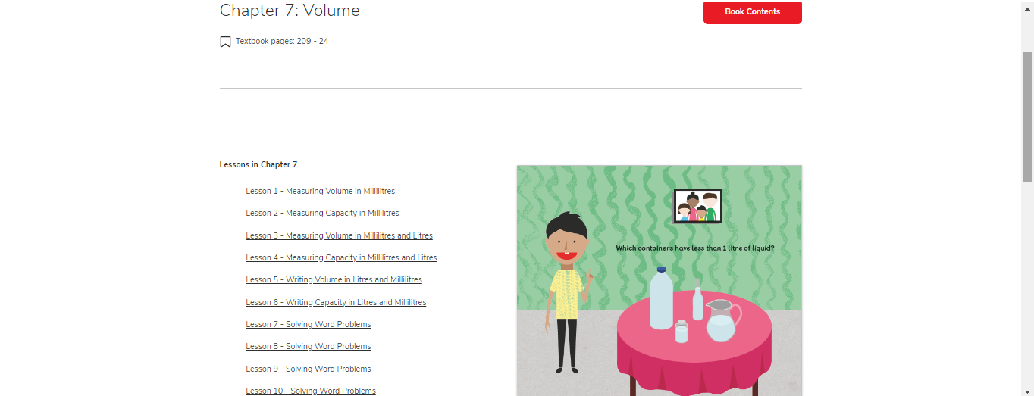
Each chapter is then split up into lessons. You can select the lesson you are given by the Year Group Team.
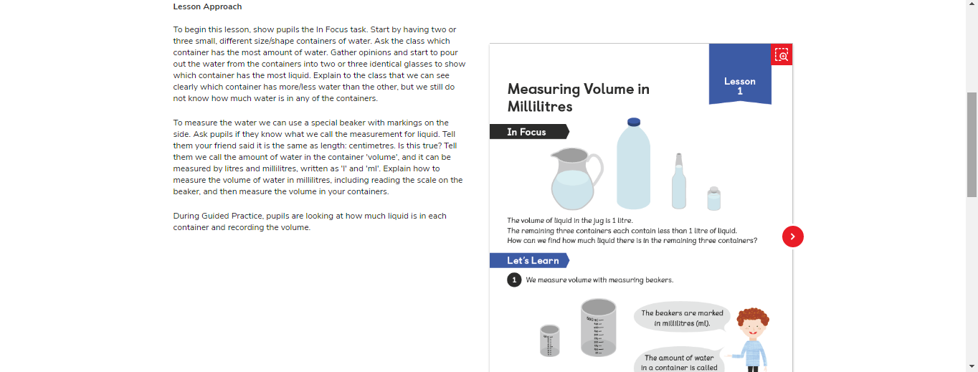 You will then be brought to the lesson page, which looks like the picture above. The section on the left under the heading Lesson Approach is what the teachers would usually do with the children. You can use this to help you through. There may be other help-sheets on the school website to help also.

Breakdown of MNP Lessons
- In Focus Task
This is the problem we start every lesson with. We usually get the children to talk about what they know already and what they think they know about it before going about with the task.

- Let’s Learn

These steps usually show how we should go about answering the questions. They may show some manipulatives we usually use in school which you may not have, such as counters or cubes. You can find simple apps online to replicate these if you need to. Look at these if your child needs a bit of help solving the problem.

- Guided Practice
This is usually the section where we answer some questions together, using what we have discussed using Let’s Learn to help. You may want to work with your child during these questions. The button at the top labelled Answers will put the answers into the blue boxes to check if you are right. It may also supply the working out you could do to answer it. If your child got the right answer with a different method, then allow them to use that if they continue to get the right answers. If not, then encourage them to use the method shown. There are sometimes multiple pages to complete.
After you have finished all of the questions, you will notice a link at the top of the page which says Go to Workbook. You should now click on this to continue.
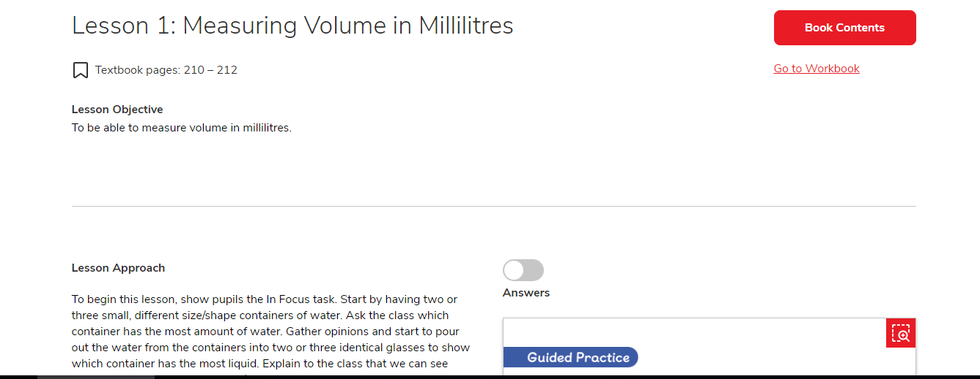

- Independent Practice
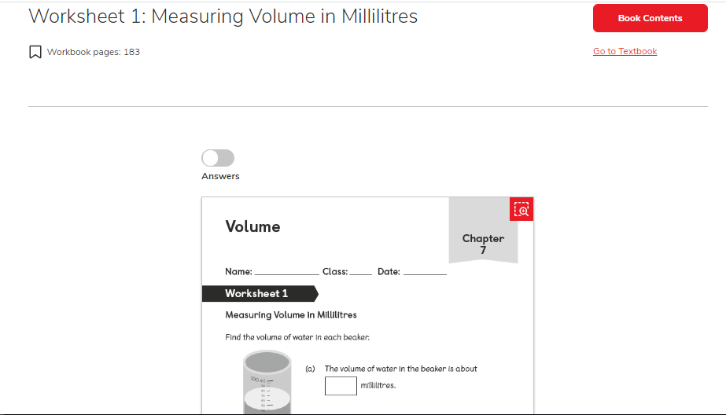

This section is usually completed by the children independently, using the strategies we have looked at previously. Again, their answers can be checked by using the button at the top. Some questions are intended to challenge the children, so don’t be alarmed if your child can not answer some of the questions.

We hope that this guide is helpful during this time. We are here to help in any way if we can. Thanks for all your assistance.
The St Luke’s Team.

