Areas of the curriculum to be taught separately  RE – Why is Jesus inspiring to some people?  Maths  – Numbers Up to 10,000 including place value knowledge  -Addition and subtraction within 10,000  Games/PE  - Games: Tag Rugby  - Dodgeball  Music  Based on a River song.  PSHE  Friendships  Buddies  We will have ‘Buddy Time’ with our Reception Buddies. To help them settle in, we will share story books. | 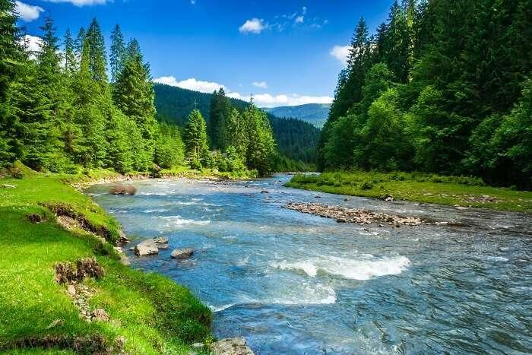 |  | Rivers
Main Curriculum Focus
In English, we will use a range of nonfiction and fiction texts on rivers, from which the children will produce a variety of writing.
In science, we will look at the properties of solids, liquids and gasses and use this to compare and group objects. We will look at how temperature affects the state of a material, focusing on what happens when you heat or cool materials. We will also look at evaporation and condensation and their importance in the water cycle.
In geography, we will look at the features of UK rivers, as well as their roles in the water cycle.
In computing, we will be looking at The Internet.
In Art, we will be exploring pattern.
 | L.E.A.R.N.  This half term we continue to focus on all aspects of LEARN We will promote and celebrate each strand across the curriculum. | How you can help at home  Please help your child by:  - learning times-tables  - learning spelling brought home through dictation.  - Regular reading at home, to help improve their reading fluency and understanding.  - Helping your child to tell the time.
Our Year 4 Christian value is ‘Hope’.

