Maths Key Skills Stage 5: Skill Check 12

Name: ___________________________________ Date: _______________ Class/Group: _______________________________

A: Place Value, Add and Subtract |  | B: Multiply, Divide and Fractions |  |  | C: Measure, Geometry and Statistics
1. What is the value of the 7 in this number? 7,186,354 | 5:1 | 11. Write all of the factors of 26. |  | 5:8 | 21. If 4 litres is approximately 7 pints, about how many litres are equal to 21 pints? |  | 5:20
2. Put these in order, smallest first: 1,012,685 99,956 867,600 1,300,423 | 5:1 | 12. Which of the following are prime numbers? 17 21 23 25 27 |  | 5:9 |  |  | 5:20
3. Round 596,147 to the nearest ten thousand. | 5:2 | 13. 4,170 ÷ 6 |  | 5:10 | 22. Calculate the area of this rectangular field:  25m  10m |  | 5:21
4. What is the missing number?  53,450 54,450 56,450 | 5:2 | 14. 1.04 x 100 |  | 5:11 |  |  | 5:21
5. Put these in order, smallest first:  -10, -3, -2, -7, -9, -6 | 5:3 | 15. What is 1³ ? |  | 5:12 | 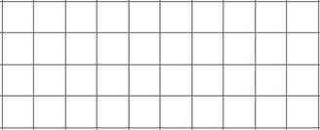  23. Reflect the shape in the mirror line. |  | 5:28
6. What year is represented by these Roman Numerals? MMIX | 5:4 | 16. Put these in order, smallest first:  5  6  16  18  8  12  2  8 |  | 5:13 |  |  | 5:28
7. 212,190 – 14,085 = | 5:5 | 17. Find an equivalent fraction of . |  | 5:14 | 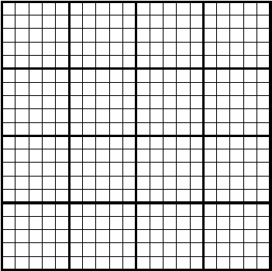  24. Rose recorded her height each year:  Height (cm)  140  135  130  125  0  Between  which two  7 8 9 10  Age  ages did  Rose grow  the most?  25. How much taller was Rose at the age of 10 than when she was 7? |  | 5:29  5:29
8. 63,460 + 17,175 = | 5:5 | 18. Write the answer as a mixed number.  12  15  6  15  + |  | 5:15 |  |  | 5:29  5:29
9. Complete this sum without written working. 20,500 - 6,200 = | 5:6 | 19.  5  11  x  =  44 |  | 5:16 |  |  | 5:29  5:29
10. The temp. was -9°C. It rose by 8°C, then dropped by 10°C. What is it now? | 5:7 | 20. Write 0.83 as a fraction. |  | 5:17 |  |  | 5:29  5:29
Total (A) |  | Total (B) |  |  | Total (C)
Test Total (A+B+C) |  | R (0-9) | Y (10-19) |  |  | G (20-25)

