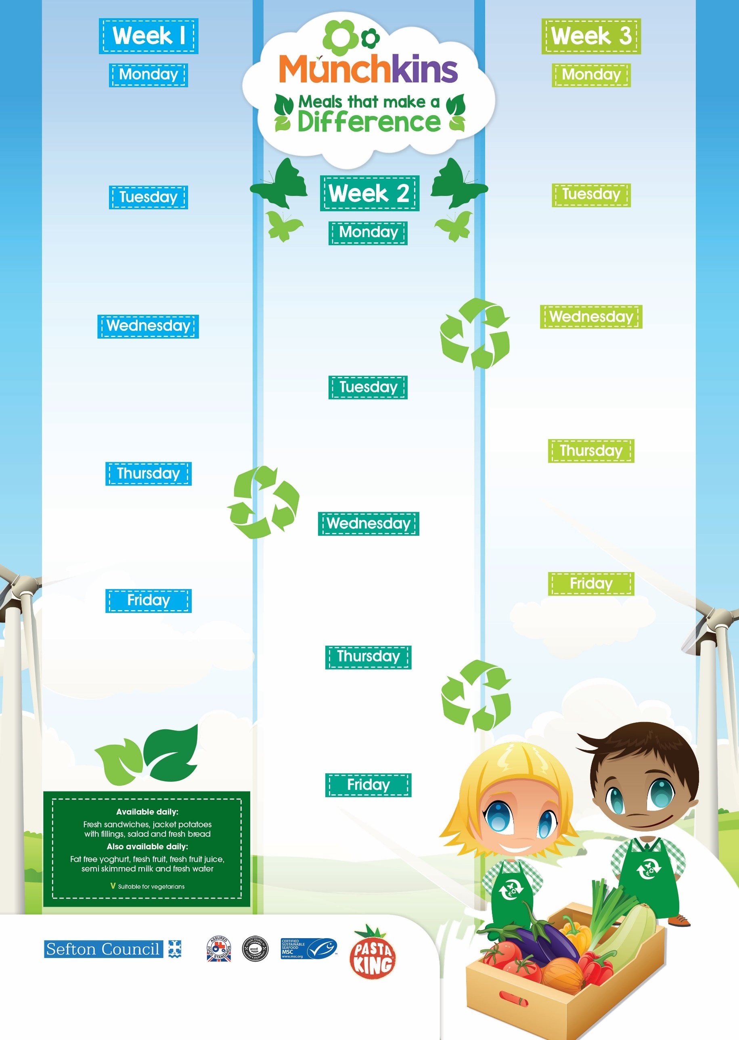

**Oven Baked Sausages, Mashed Potatoes, Garden Peas**

**V Veg Curry & Rice, Naan Bread**

**Homemade Mini Biscuit**

**& Fruit Slice**

**Fishy Friday, Garden Peas & Sweetcorn , Chips**

**V Tuna Pasta**

**Chocolate & Banana Brownie**

**Big Breakfast**

**Tuna Pasta Bake & Crispy Salad**

**Oat, Apple & Honey Slice**

**BBQ Chicken with Sunshine   
Vegetable Rice**

**V Mac & Cheese with Mixed Salad**

**Shortbread Biscuit**

**Fruity Flap Jack**

**Cook’s Choice Pizza, Coleslaw, Salad, ½ Jacket Potato**

**V Tomato & Basil Pasta, Roasted Veg, Crispy Salad**

**Peach & Pineapple Flapjack**

**Sausage & Tomato Pasta,**

**Mixed Salad**

**V Veggie Cottage Pie & Greens**

**Fruity Oat Cookie**

**Chicken Tikka Curry, Boiled Rice, Naan**

**V Pizza Pockets, Salad Sticks, Potato Wedges**

**Vanilla Cupcake**

**Roast Chicken & Gravy, Sweetcorn,**

**Green Beans, Paprika Potatoes**

**V Quorn Bolognaise with Pasta & Onion Bread**

**Jam Sponge & Custard**

**Meatball Pasta**

**V Cheese & Onion Sausage Roll & Wedges**

**Frozen Yoghurt Pot**

**Fishy Friday, Garden Peas, Chips Potatoes**

**V Tuna Pasta**

**Cookie**

**Fishy Friday, Mushy Peas, Chipped Potatoes**

**V Tuna Pasta**

**Fairy Cake**

**Chicken Korma with 50/50 Rice,**

**Naan Bread**

**V Cheese & Potato Puff,**

**Baked Beans**

**Ice Cream Pot**

**Honey Glazed Gammon, Vegetables, Paprika Roast Potatoes & Gravy**

**V Quorn sweet & sour & rice**

**Jam Sponge & Custard**

**Beef Lasagne & Garlic Bread, Side Salad**

**V Chunky Veg Curry with 50/50 Rice, Naan Bread**

**Fruit Sponge & Custard**

**Roast Turkey, Carrots & Peas,   
Roast Potatoes**

**V Quorn & Bean Chilli with Boiled Rice**

**Fruit Jelly & Cream**