 North Sefton

Personal Challenge

‘Long Jump’

How many 2-2 footed jumps does it take you to jump the British Long Jump Record??

Men-Greg Rutherford 8.51cm

Women- Jasmin Sayers 6.61cm

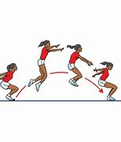

Equipment-Tape Measure to measure the British Record and your own jump. If you do not have a tape measure the average adult stride is 1m.



Please share your challenges on Twitter: I would love to see them ☺

North Sefton School Games @NorthSeftonSG