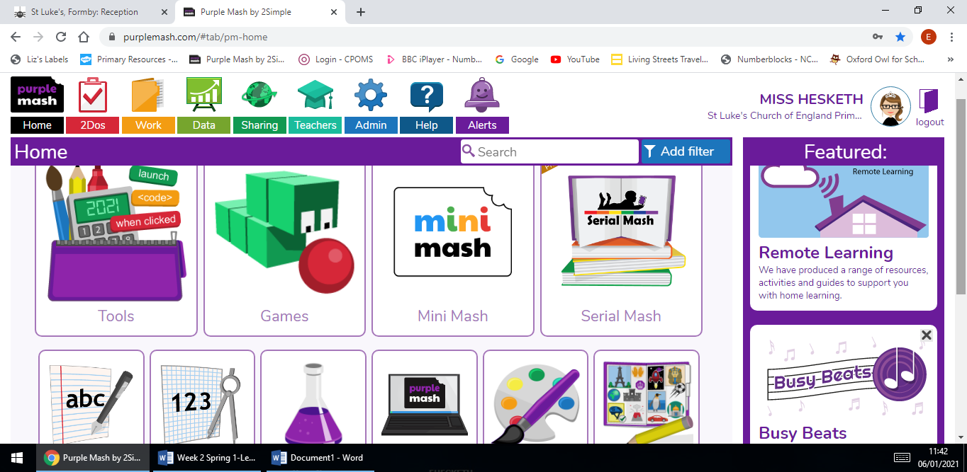
Log onto your Purple Mash account. Your log in details are inside your home learning journal.

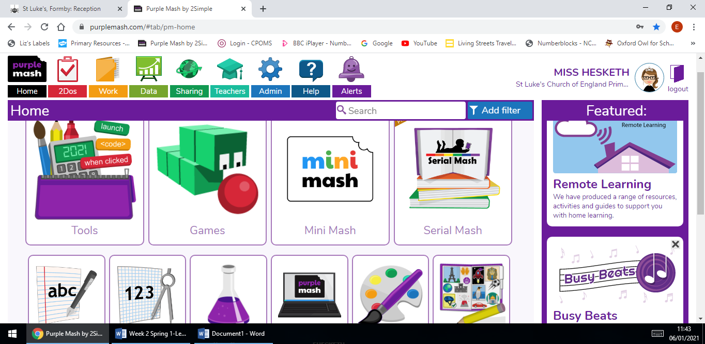
Click ‘work’ at the top of the page.

- 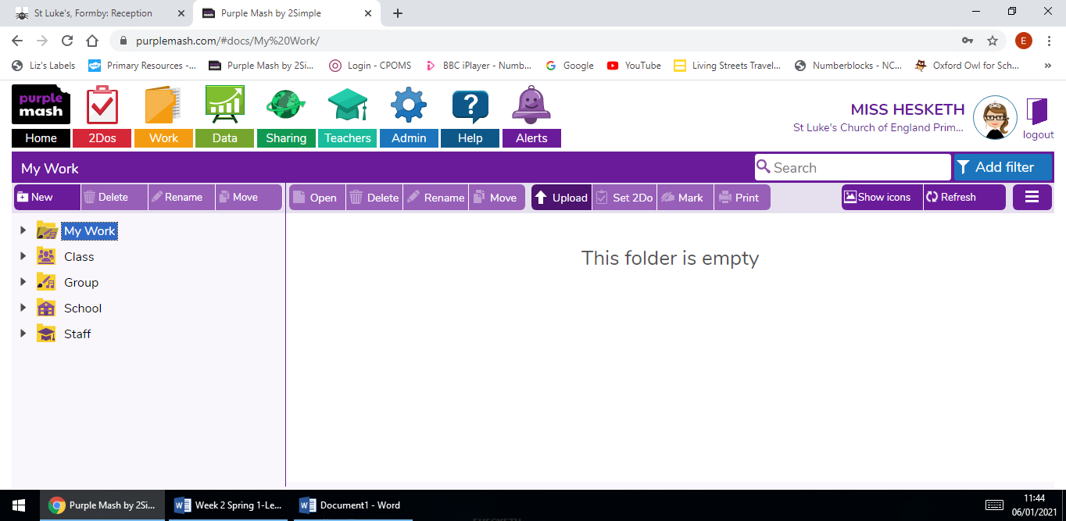
Click the ‘Upload’ button.
- 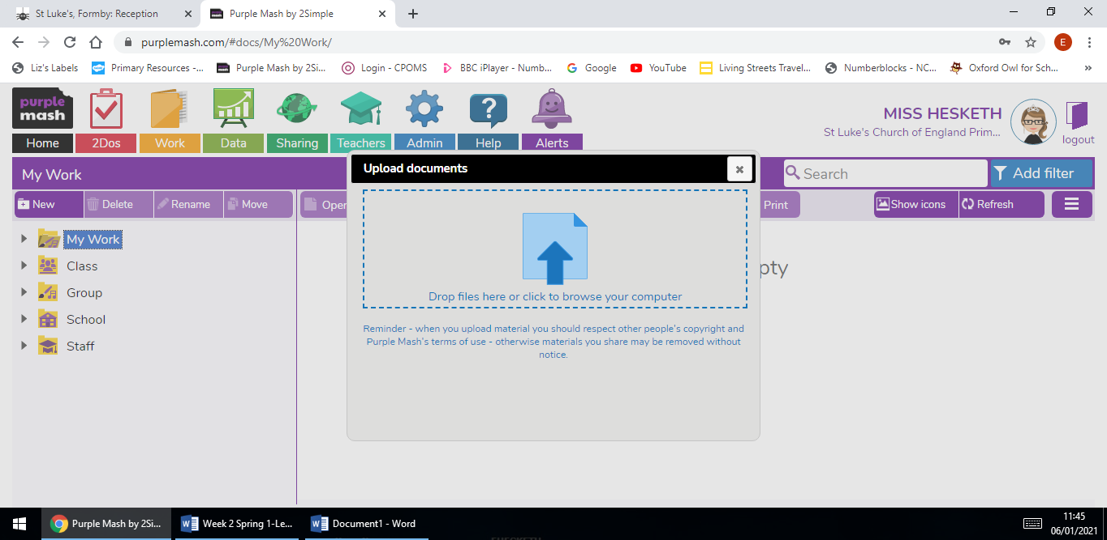
Click ‘drop files’ to browse for the picture you have taken.
- 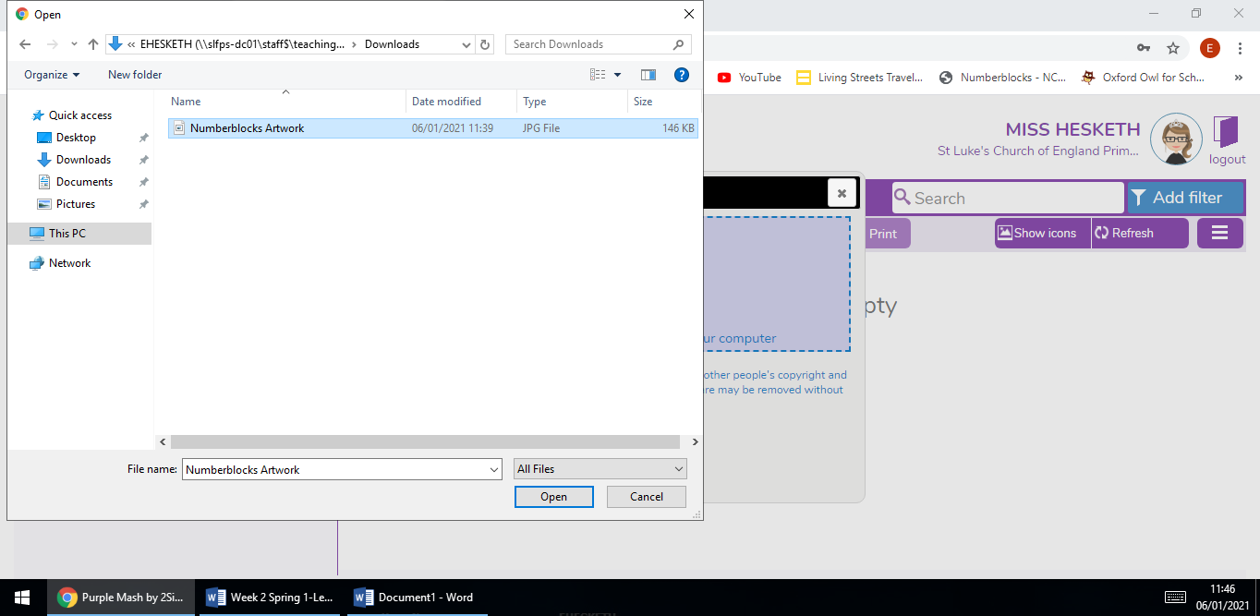
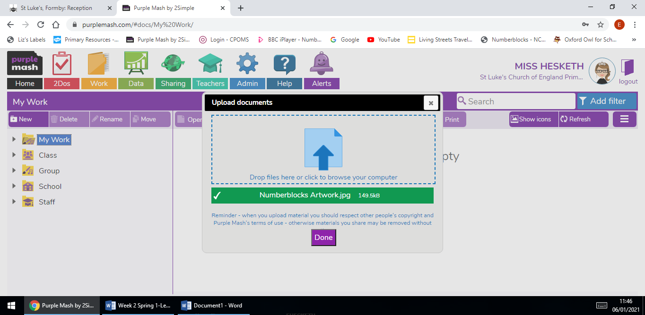
Choose the file and click open, you should then see it has uploaded successfully. Then click done and your work will be saved.
- 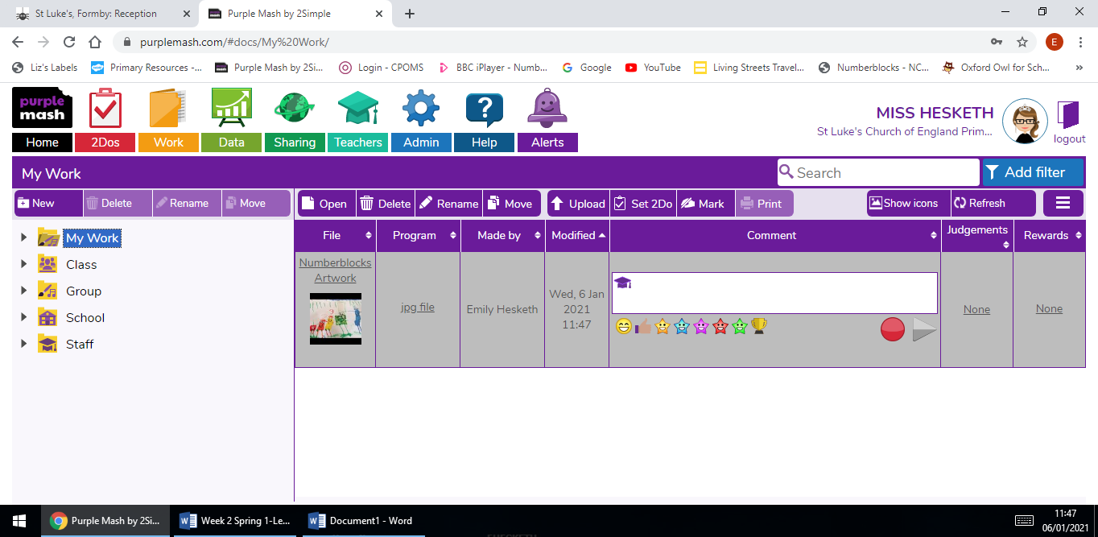
Finally, you can leave your teacher a message, or leave them a voice note along with your work to explain what you have created. Your teacher can leave you a comment when they have seen it!

You can upload anything you want, whether it is a picture of you on a walk, in the garden and anything you have got up to. We look forward to seeing them.
Have fun!

