1.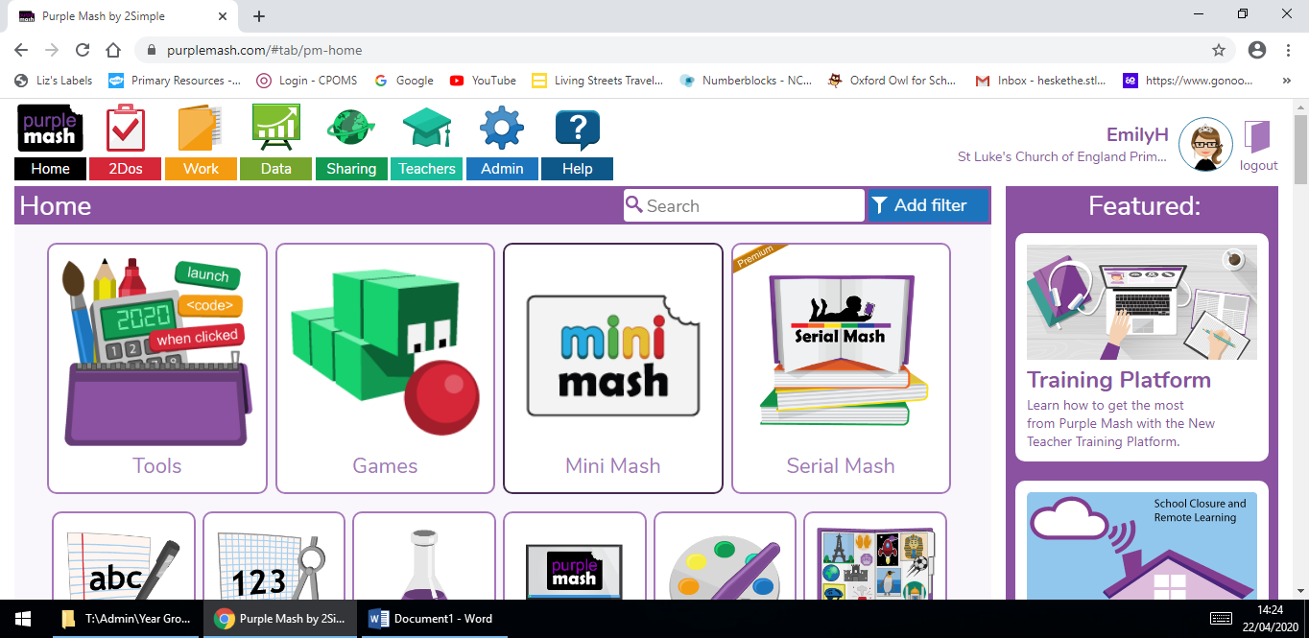
Enter Purple Mash using the login details on the inside of your home learning journal.
Click the ‘Mini Mash’ button.
2.
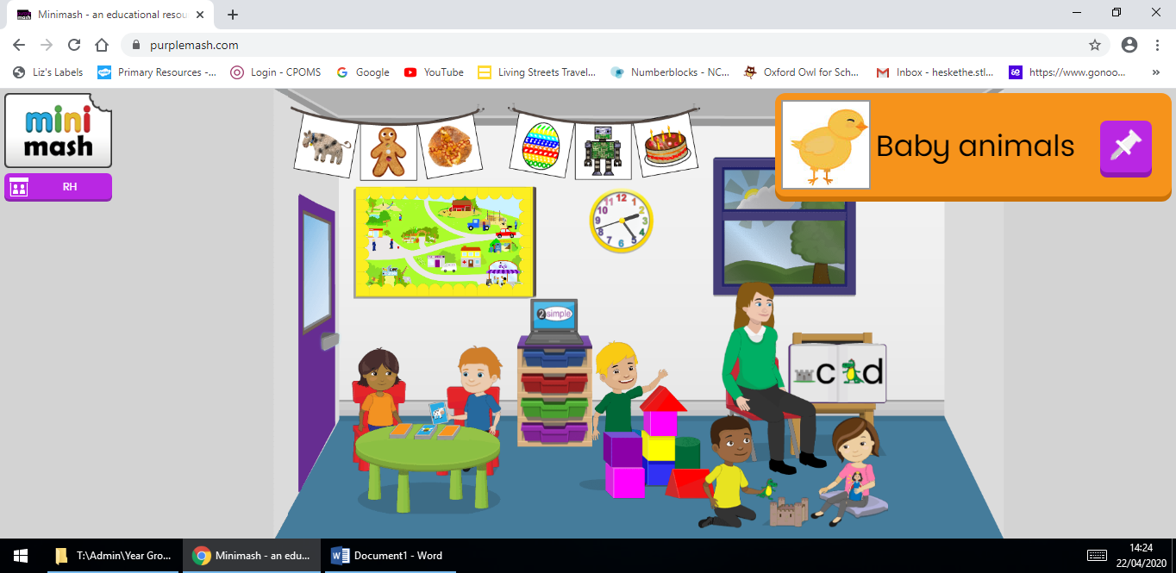
Here you will find lots of interactive games and activities.
If you create something you would like your teacher to look at, you can save it in your tray.

3.
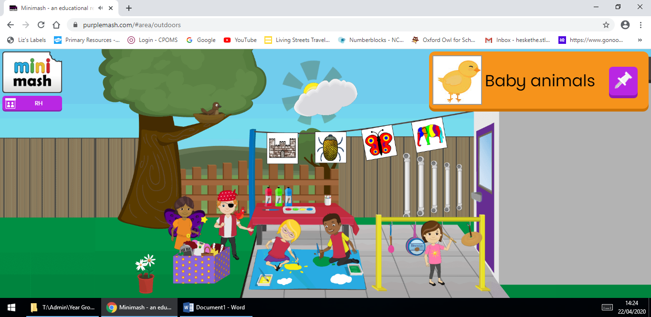
You can click the door and explore activities in the garden of Mini Mash.
4.
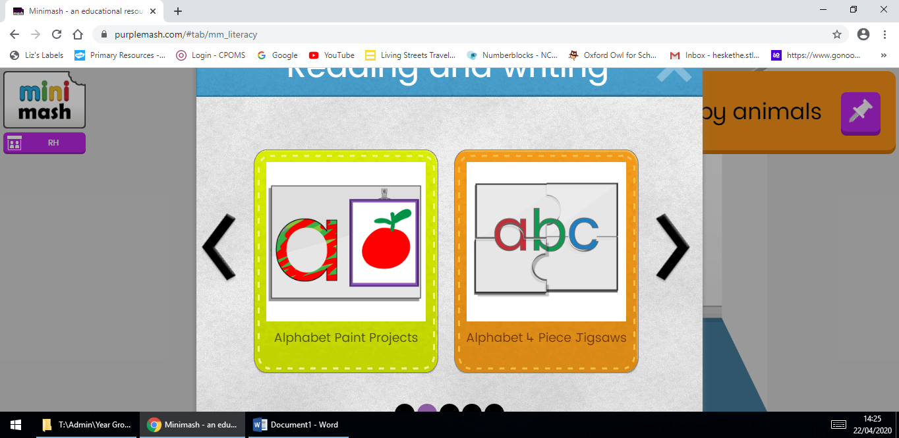
Choose an activity by scrolling over all the different characters and objects, I chose an ‘Alphabet Paint Project’.

5.
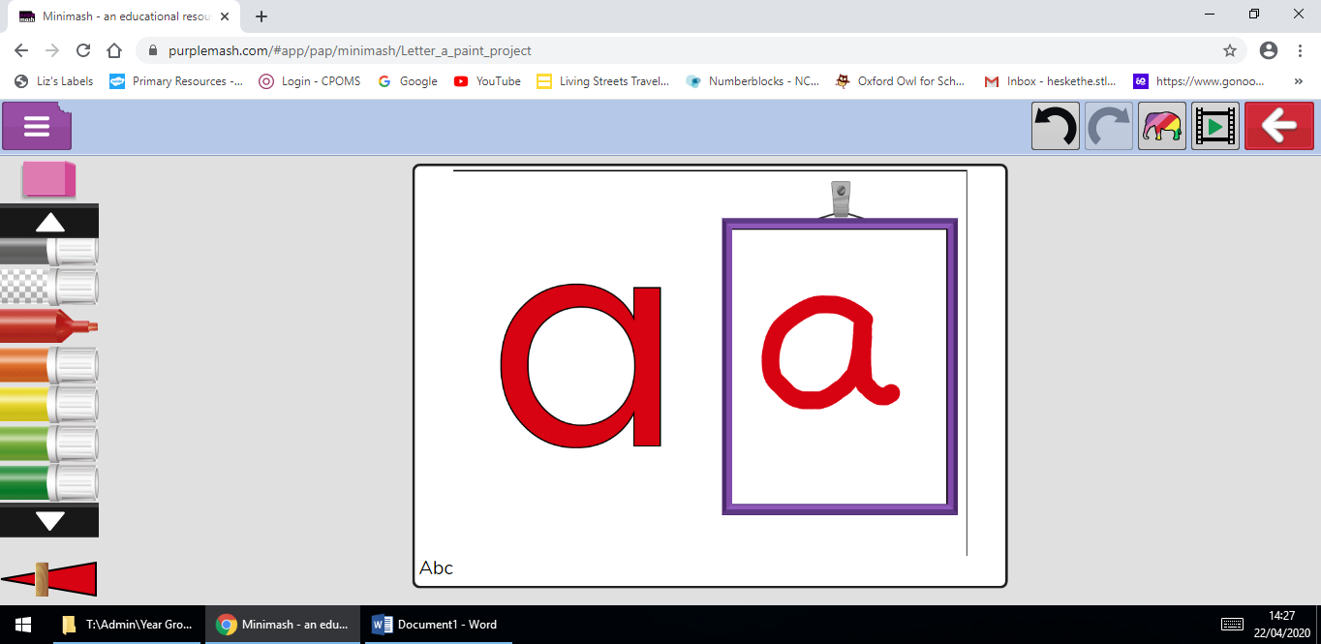
Here you can practise your letter formation and ICT skills.
6.
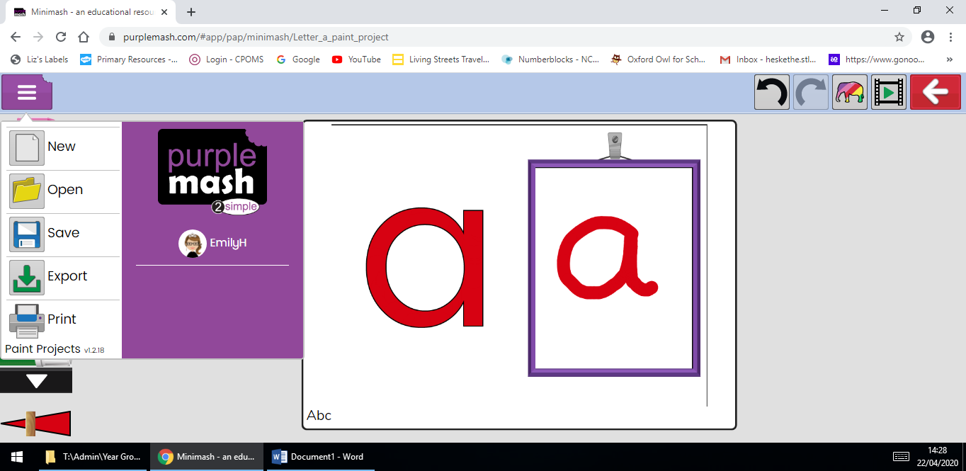
You could leave your teacher a message where it says ‘Abc’.
Once you have created your masterpiece, click save.
7.
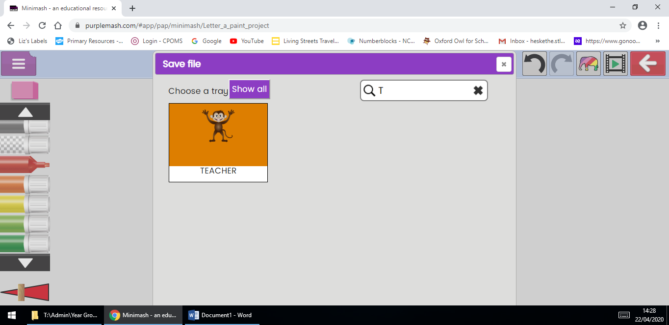
Find your personal tray by searching your name. You should see your animation and your name appear.

Your teacher will look regularly in your trays to see what you have been creating!
Have fun :)

