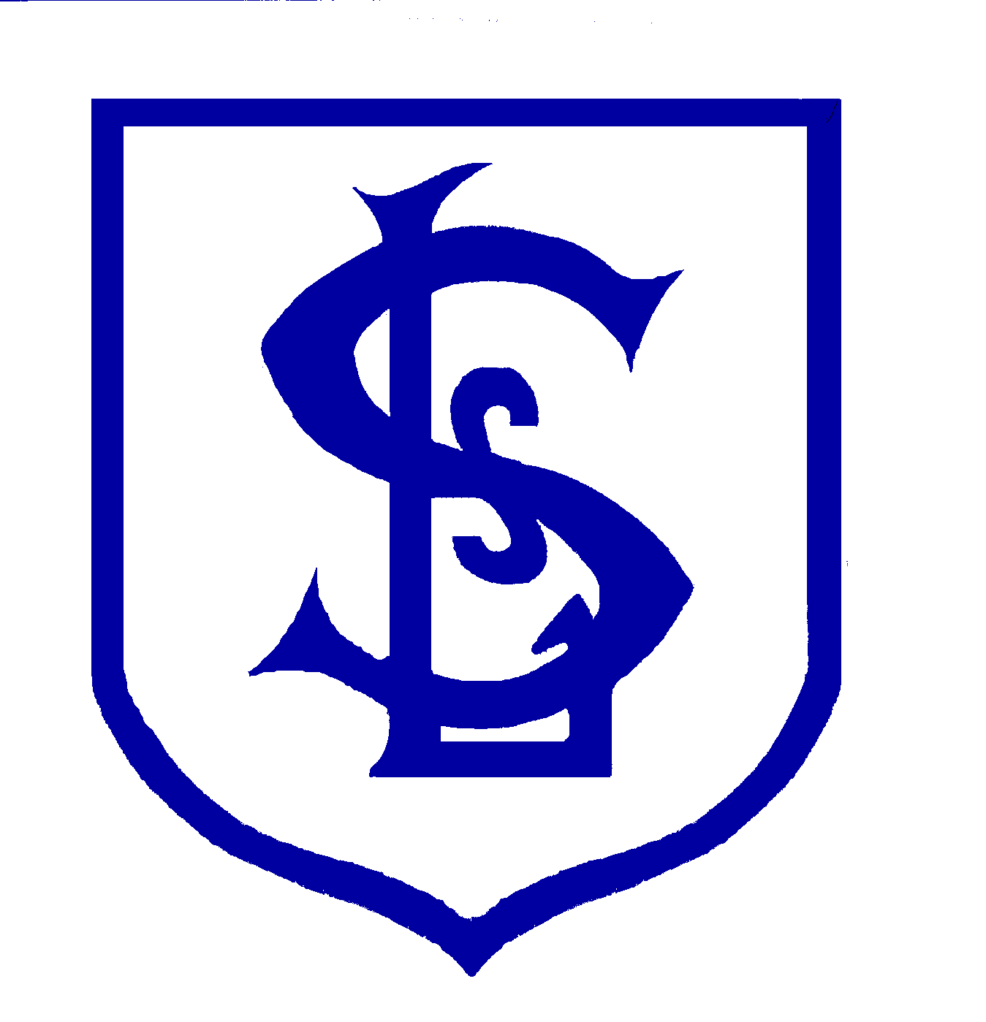St. Luke's CE Primary School
Jubilee Road, Formby, Merseyside, L37 2HW
Telephone: 01704 872692 Fax: 01704 831745
Email: admin.stlukesformby@schools.sefton.gov.uk
www.stlukes-formby.co.uk

Headteacher: Mrs. Sharon Cowey, MA, NPQH

13th March 2020

Coronavirus Covid-19 Update

Dear Parents and Carers,

I am writing to update you on how we intend to respond to the unfolding situation regarding Coronavirus Covid-19.

As I’m sure you will appreciate, we are currently dealing with a complex and rapidly changing situation. My first priority will always be the health and safety of the pupils and staff in our school. Now more than ever, this remains our primary focus. This is an entirely unprecedented situation and we are following official advice from the government and the NHS. This advice is being added to on a daily basis and we are monitoring and responding to that as it is published.
This official advice will underpin all the actions we take. Whilst I appreciate that there will be a wide range of different views about how we should be responding and what action should be taken, I hope you will appreciate that I am duty bound to follow the official advice from government.

Latest government advice:
No education setting should close in response to a suspected or confirmed COVID-19 case unless advised to do so by Public Health England.
The Chief Medical Officer has advised that the impact of closing schools on both children’s education and on the workforce will be substantial, but the benefit to public health may not be. Decisions on future advice to schools will be taken based on the latest and best scientific evidence, which at this stage suggests children are a lower risk group.
To support the delay of the spread of the virus, the Department for Health and Social Care has asked anyone who shows certain symptoms to stay at home for 7 days, regardless of whether they have travelled to affected areas. This means people should stay at home and avoid all but essential contact with others for 7 days from the point of displaying mild symptoms, to slow the spread of infection.
The symptoms are:
- A high temperature (38 degrees and above) and/or
- A new, continuous cough
You do not need to call NHS 111 to stay at home. If your symptoms worsen during your stay at home period or are no better after 7 days contact NHS 111 online at 111.nhs.uk. If you have no internet access, you should call NHS 111. For a medical emergency dial 999.
Hand and Respiratory Hygiene
It goes without saying that hand and respiratory hygiene is fundamental to preventing the virus spreading. All pupils should bring tissues to catch a sneeze or cough and wash their hands on a regular basis throughout the school day using soap. Staff ensure this happens on arrival at school, after breaks and before lunchtime (and on arrival at Fun Club). Staff are also discouraging pupils from touching their faces and encouraging them to eat with a knife and fork.

Self-Imposed Isolation
As above, if your child is experiencing a ‘new, continuous’ cough or high temperature please do not send him / her into school for seven days. Similarly, we will contact you and ask you to collect your child from school if he / she presents with these symptoms.

Limiting Contact
In order to limit pupils’ contact with one another as much as practicable, from next week we will we not be holding whole school assemblies and we have reluctantly decided to postpone the Y5 Show till the summer term and to cancel the Y4 Easter Services.

Staff Absence
In the event of high levels of staff and pupil absence from school over the coming weeks we may need to consider changing elements of the timetable and deploying teachers to different groups of children. As such, it would be helpful for children to have their games kit in school every day, please.

I trust the information outlined in this letter is helpful and that you will understand the rationale behind the measures we have taken. I will write again in the near future to provide further updates.

Yours sincerely,

Sharon Cowey
Headteacher

