**Converting measurements:**

**Length**

1cm = 10 mm 1mm = 0.1 cm

1m = 100cm 1cm= 0.01m

1m = 1000mm

1Km = 1000m 1m= 0.001 Km

**Mass**

1Kg = 1000g 1g=0.001 Kg

Capacity

1L = 1000ml 1ml = 0.0001L

**Time**

1 day = 24 hour

1 hour =60 mins

1min = 60 sec

**Fractions, Decimals and Percentages**

$\frac{1}{10}$ =0.1 =10%

$\frac{1}{100}$ =0.01 =1%

$\frac{1}{1000}$ =0.001 = 0.1%

$\frac{1}{2}$ = 0.5 = 50%

$\frac{1}{4}$ = 0.25 = 25%

$\frac{3}{4}$ = 0.75 = 75%

$\frac{1}{5}$ = 0.2 = 20%

$\frac{1}{8}$ = 0.125 = 12.5%

$\frac{1}{20}$ = 0.05 = 5%

**Maths Key Facts Sheet**

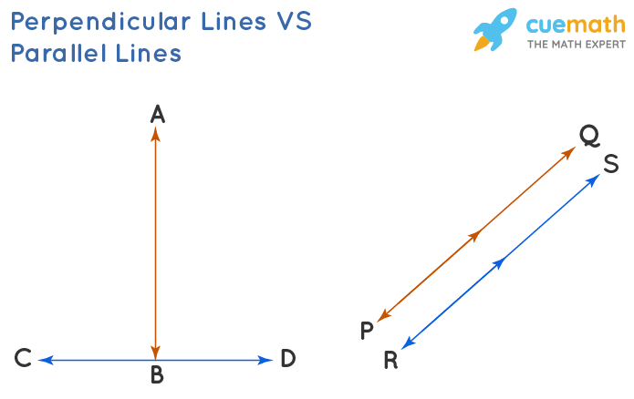

Perpendicular Parallel

