Phonics Screening Success Homework

Scan the QR codes with a device and watch the videos at home regularly for extra reading practice!
(These QR codes will expire on 10th July 2023).
Practise reading

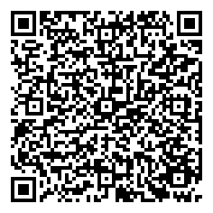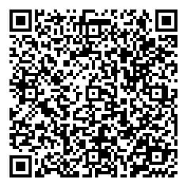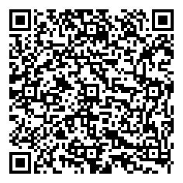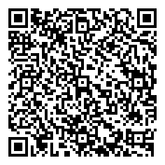

Watch each film to help your child apply their amazing phonic skills!

